Projectile Motion

Physics 2211: Nathan Harrison

Marlynn Sanchez

09/22/19

**Projectile Motion Experiment**

**Objective:** To stimulate 2-dimennsional motion and comparing results to calculations.

**Data:**

Part 1

Height 1 = 7m

Height 2 =3m

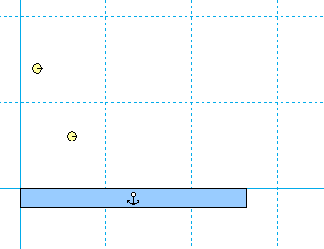

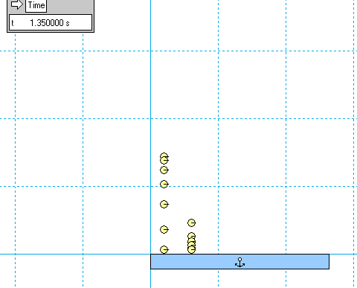

Part 2

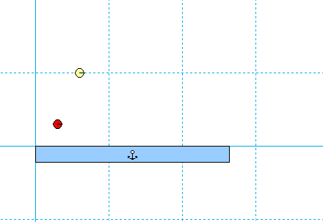

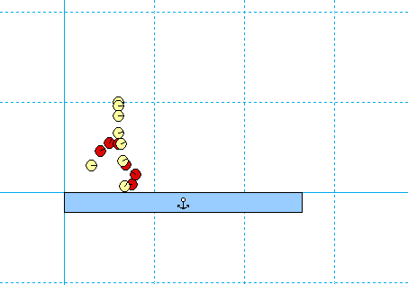

**Calculations:**

Part 1

Second height

**= V = -1.963m/s**

Part 2

Red ball

**Vx=2.5 m/s**

**Vy=5 m/s**

Yellow ball

X= 3m

V= 0m/s

**Results:**

My results in part 1 were off due to calculation errors. I calculated 1.008s as the time for the balls to hit the ground but the time was actually 1.400s.